Injury and Illness Prevention Program Quiz

Name: ____________________________

- The company safety manager’s responsibilities include

- Develop and implement rules of safe practices for each function within the company
- Develop and implement a system to encourage employees to report unsafe conditions
- Ensure the safety and health of all employees
- Investigate all employee accidents, safety hazards, near-misses
- All the above

- The employer is responsible to provide all employees with

- Safety training
- Personal protective equipment
- Work shoes
- Transportation to work site
- a and b
- b and c

- All employees have a safety responsibility and are required to

- Return from lunch and breaks on time
- Remove safety guards that slow down production
- Report any unsafe conditions to the job site supervisor and the company safety manager.
- Repair or replacement safety equipment

- If a fire alarm or alert is sounded or a fire is reported by an employee, regardless of the reason for the alarm or the severity of the fire, the following action must be taken immediately

- Immediately grab a fire extinguisher and look for the source of fire or smoke
- Check all areas of their respective departments, restrooms, and public areas to verify that employees and individuals are evacuated
- Telephones the local emergency agency (for example, fire, police, hazardous materials team, etc.).
- Immediately evacuate the building

- If trained in the use of fire extinguishers, you may attempt to suppress a small fire.

- True
- False

- Employees must report all injuries and illnesses to your supervisor, unless it’s a small laceration that only requires a Band-Aid.

- True
- False

- You have the right to know about the hazards associated with the chemicals you work with, and the safety procedures you need to follow to protect yourself from those hazards.

- True
- False

- It’s your responsibility to help your co-workers recognize unsafe actions or conditions they cause.

- True
- False

- All identified potential workplace safety and health hazards should be reported to

- Co-workers
- OSHA
- The labor board
- Supervisor, safety manager or member of the management

- MSDS stands for?

- Micro Soft Data Safety
- Manufacturer Safety Disclosure Sheet
- Material Safety Data Sheet
- Material Safe Date Sheet

- OSHA’s Hazard Communication Standard, 29 CFR 1910. 1200 requires

- All chemical containers to be clearly labeled as to the contents
- Note the appropriate hazard warning
- List the name and address of the manufacturer
- All the above
- a and c

- GHS is a system that’s been created by the United Nations for standardizing the classification and labeling of chemicals throughout the world.

- True
- False

- Employers are required to have a hazardous chemical inventory list of all known hazardous chemicals used by employees. Further information on each noted chemical can be obtained by reviewing the MSDS or SDS located at the work-site location.

- True
- False

- Approved eye protection (safety glasses with side shields, goggles, etc.) must be worn at all times when the risk of eye injury is present.

- True
- False

- When lifting heavy boxes or material, Keep the back straight, stand close to the load, and use your leg muscles to do the lifting, keeping the load close to the body. Never twist your upper body while carrying a load.

- True
- False

- A _________ ____________ is a person who locks out or tags out machines or equipment in order to perform servicing or maintenance on the machine or equipment. An ________ _______ becomes an authorized employee when the employee’s duties include performing servicing or maintenance.
  - Authorized personnel, affected employee
  - Service personnel, operations manager
  - Service representative, industrial hygienist
  - None of the above

- An affected employee can perform maintenance on a machine or equipment without the proper training or authorization of the employer.
  - True
  - False

- At what temperature shall the employer implement high-heat procedures?
  - 80 degrees
  - 95 degrees
  - 100 degrees
  - 105 degrees

- If you identify a co-worker exhibiting signs of a heat related illness, you should?
- Tell them to keep working
- Dump cold water on them
- Immediately report to the supervisor
- None of the above

- Safety Data Sheet (SDS) is a document that contains information on the potential hazards (health, fire, reactivity and environmental) and how to work safely with the chemical product. MSDS format has now been replaced by new SDS format. Please check all of the items below that you will find on the new SDS format.

 Danger  Warning  Chemical Name  Product Name  Manufacturer

- 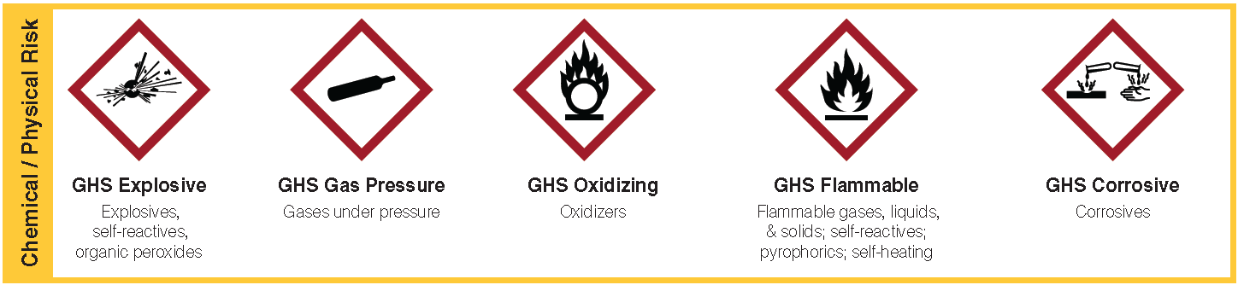
- 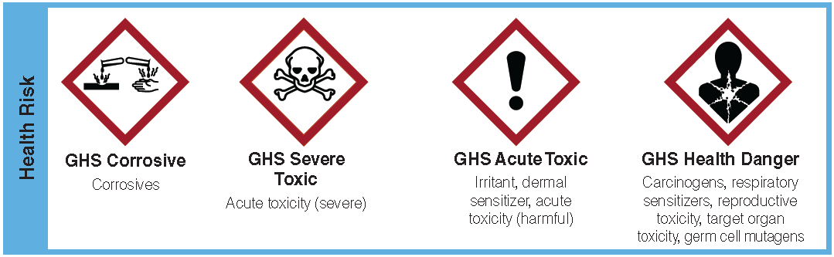

Employee Name: __________________________________________

Employee Signature: _______________________________________ Date: ___________________

Trainer Name: ____________________________________________ Date: ___________________

