Employee Handbook
01/01/17 EDITION

Corporate Headquarters,

Southern California Sales and Recruiting Office
11208 Whittier Blvd
Whittier, CA 90606
(562)568.0157 Office (562) 568.0158 Fax

WWW.ELITE-LABOR.COM

Welcome!
Welcome to Elite Labor Solutions, Inc! For over 12 years, Elite Labor Staffing has been the leader in Industrial Staffing. Headquartered in Whittier, Elite Labor Staffing was founded to serve you in your pursuit in the light industrial, manufacturing, distribution, administration and Management fields. Expect to be treated with respect by a company that adheres to its values and benefit from Elite Labor Staffing’s reputation for having the most qualified recruiting professionals since 2004.

Professional growth amongst our employees is important to Elite Labor Staffing. We have hired and trained seasoned recruiters who have strong connections with job fairs, job posting, advertising, screening, headhunting, social media and much more resources so that a career can flourish and grow at Elite Labor Staffing. You can rely on Elite Labor Staffing’s recruiters, resources and industry knowledge to:

- Maximize your earning potential
- Identify positions that will further your expertise
- Find satisfying work environments where you’ll thrive

Elite Labor Staffing is committed to matching your talents to career opportunities. The advantage of working with Elite Labor Staffing is that your recruiter can offer advice to increase your success, find out if an employer is interested in converting a temporary position to a direct hire, negotiate salary and provide support in assuring your long-term success. We hope your time at Elite Labor Staffing will provide you with longevity and a career path in the position that best fits your skills.

COPYRIGHT© 2017 by Elite Labor
All Rights Reserved
All Rights Reserved. No part of the book may be reproduced in any form or by any means, electronic or mechanical, including photocopying, recording or by any information storage system, except by a reviewer who may quote brief passages in a review to be printed in a magazine or newspaper, without permission from the publisher.

Published by
Elite Labor Solutions, Group

TABLE OF CONTENTS

Contents
Elite Labor Staffing 2
Corporate Headquarters, 2
Southern California Sales and Recruiting Office 2
WWW.ELITE-LABOR.COM 2
THE APPLICATION PROCESS 6
Resume 6
Employee Application 6
W-4 Form and State Tax Form 6
I-9 Proof of Citizenship or Legal Resident Alien Status 6
Consent for Background Search Form 6
Drug Testing 6
Reference Forms 6
Skills Assessment 7
Job Duty Exclusion List 7
Staff Interview of Candidate 7
TIPS FOR TEMPS 8
Payroll 8
Timesheet Instructions 8
Overtime Issues 8
Meal & Rest Breaks 8
Payday Schedule 8
Holiday Pay 8
Absences / Tardiness 9
Benefits 9
Unemployment Insurance 9
Stop-Payment of Paycheck 9
Before Beginning An Assignment 9
Directions 9
Orientation 9
Job Cancellations 9
When Do I Get To Go To Work? 10
Availability Notification 10
Onsite Policies 10
Injury While on Jobsite/Workers Compensation Insurance 10
Client Property 10
Handling of Cash and Money Orders 10
Computer And Email Usage 10
Dress Code 10
Safety Plan Issues 11
Phone Numbers 11
Personal Phone Calls from Work Site 11
Use of Mail System on Work Site 11
Personal Emergencies 11
Gossip 11
Business Ethics and Conduct 11
Appendix A 14
EEOC Policy 14
Appendix B 15
Company Policy Against Discrimination and Harassment 15
Appendix C 16
Substance Abuse Policy 16
Employees of Elite Labor who refuse to submit to drug testing, test positive or admit to substance abuse will be subject to termination. 16
Appendix D 17
General Safety Rules 17
Appendix E 18
Employee Payroll Policies 18
Appendix F 19
Tsheets Timecard Employee’s Guide 19
Appendix G 22
Job Duty Exclusion List 22
Appendix K 22
Orientation Attendance 22
Appendix L 23
Certificate of Acknowledgement of Receipt of the Employment Handbook and Review of Elite Labor Solutions, Inc. General Policies and Procedures 23
Appendix M 24
Occupational Medical Facilities 24
NOTES 25

THE APPLICATION PROCESS

Resume
All candidates shall have on file with Elite Labor Solutions, Inc a current resume that includes past employment history as well as duties, accomplishments, titles and areas of expertise. Every resume shall contain all certificates, licenses and professional designations held by the candidate. Professional looking resumes more effectively communicate your talents to a hiring authority.

Employee Application
All candidates must fill out the standard Elite Labor application form. Completed applications are used to accurately document your employment and educational history.

W-4 Form and State Tax Form
All candidates for employment shall fill out a current W-4 form and any applicable state tax form so that Elite Labor can withhold the correct federal income tax from your pay.

I-9 Proof of Citizenship or Legal Resident Alien Status
Elite Labor complies with the Immigration Reform and Control Act, and accordingly requires all candidates to provide verification of authorization to work in the U.S. before Elite Labor is able to place you on an assignment. Examples of acceptable identification include: Driver’s License, Government issued I.D. card, Social Security Card, birth certificate, U.S. Passport or Permanent Resident Card. (See I-9 form for complete list of acceptable forms of identification.)

Consent for Background Search Form
All candidates must sign and date a consent form, either in writing or electronically, giving Elite Labor permission to conduct a background search prior to employment. Elite Labor is free to hire a service of our choosing to conduct this search. The candidate will not be charged for this service. The candidate and/or employee must have and maintain a background screening clear of any criminal convictions, including but not limited to felony and misdemeanor convictions, in order to be employed by Elite Labor.

Drug Testing
Elite Labor is committed to providing a safe, efficient and productive work environment for all employees. Using or being under the influence of drugs or alcohol on the job may pose serious safety and health risks. To help ensure a safe and healthful working environment, candidates may be asked to provide body substance samples (such as urine and/or blood) to determine the presence of illicit or illegal drugs or alcohol. Elite Labor will require a drug screen test whenever an on the job accident or injury occurs, according to Elite Labor company Substance Abuse policy. In addition, some Elite Labor clients require that all candidates be administered and pass a drug test before being placed at their job site. See Appendix C for complete Elite Labor Substance Abuse Policy.

Reference Forms
Elite Labor requires each candidate to provide two professional references from past employment supervisors. Candidates will be provided forms to complete with professional references contact information including their name, address, zip code and phone number. A candidate’s application will not be processed until valid references have been provided and contacted.

Skills Assessment
Elite Labor provides each candidate with a skills checklist in order to better assess your ability to perform designated jobs. In addition, Elite Labor requires each candidate to test for stated skills. Office skill tests are computerized; Maintenance and Property Management skills tests are hand written. All tests will be administered and scored prior to employment to ensure an appropriate job placement.

Job Duty Exclusion List
All employees are required to acknowledge the Job Duty Exclusion List which lists job duties temporary employees are restricted from performing while on assignment.

Staff Interview of Candidate
All candidates are required to complete an in person interview with a Elite Labor recruiter in order to be placed by Elite Labor on assignment.

TIPS FOR TEMPS

Payroll

Timesheet Instructions
It is your responsibility to submit an accurately completed time sheet via Tsheets, Elite Labor’s online timesheet system
  - Timesheets must be submitted electronically through Tsheets by end of business on Friday.
  - Timesheets must be approved by an authorized employee of the client firm; incorrect timesheets will be rejected and the employee will be responsible for promptly submitting a corrected timesheet.
  - Check your paycheck envelope for important payroll schedule changes.
  - See Appendix E for additional Employee Payroll Policies.
  - See Appendix F for instructions on accessing Tsheets.
  - Falsified or altered timesheets will not be accepted and could result in appropriate legal proceedings, including termination.

Overtime Issues
Your recruiter must approve all overtime requests before the overtime occurs. Overtime will not be paid unless your assigned recruiter and property supervisor have given you authorization to work.

Meal & Rest Breaks
California State law requires that an employee who works a six (6) hour work day take a minimum thirty (30) minute (maximum 1 hour) unpaid lunch within the first five hours of work. Note the time taken accurately on your timesheet. You may not waive your meal break if you work over six (6) hours in a day. A ten (10) minute paid rest break must be taken during every four (4) hours worked.

Payday Schedule
All paychecks are mailed from the local branch office on Thursday evening. Elite Labor has a strict policy of not allowing any checks to be picked up in the office. Schedule is subject to change, due to holidays. Elite Labor provides direct deposit services and encourages its employees to sign up for this program for quick and efficient deposit of pay.

Holiday Pay
Due to client demand, your recruiter may request that you work on a federally recognized holiday. In the event you are asked to work on a holiday, discuss pay rates and schedules with your recruiter directly.

Absences / Tardiness
When an absence or tardy occurs, communicating with your recruiter and the supervisor at your property is of the utmost importance. An absence or tardy must be reported to your recruiter and supervisor as soon as possible. Excessive and repeated absences and tardiness are grounds for possible termination of assignment.

Benefits
Elite Labor offers Temporary Employees medical and dental benefits through Vensure Limited Benefit Plan. Premiums for the Limited Benefit Plan are paid through payroll deductions.
Employees are eligible for benefits after completing 90 days of employment with Vensure. For more information regarding eligibility and enrollment speak with your assigned recruiter.

Unemployment Insurance
You may be eligible for unemployment while you work for a temporary agency as long as you follow the relevant state guidelines. When your assignment ends you may register for benefits. You may not receive these, however, if you voluntarily quit or refuse an assignment offered by Elite labor.

Stop-Payment of Paycheck
There may be a situation where you require a stop-payment of your paycheck due to inaccurate data in our database or problems with mail service. The FIRST request for a payroll check stop- payment is free of charge. Any subsequent requests will be charged $25 per stop-payment request, which will be deducted from the replacement check. Stop-payment requests cannot be made before your home mail delivery on the Tuesday following the payday. If you would like to request a stop-payment of a paycheck you must contact your Recruiter and ask for a “Payroll Check Stop Payment Request” form. The form must be completed and returned to Elite labor. A new check will be issued within 48 hours of receipt of the completed request form.

Before Beginning An Assignment

Directions
Elite Labor employees will be provided accurate directions of the property to which they are assigned by your recruiter. Check arrival times and other pertinent information contained in the job assignment with your recruiter.

Orientation
Elite Labor provides an orientation video for all new employees to view, which includes details about general safety rules and general policies and procedures.

Job Cancellations
As an employee of Elite labor, you are expected to represent the company in a professional manner. If you are unable to complete an assignment, call your recruiter immediately so other arrangements can be made. When necessary, leave a voice message for your recruiter regarding your availability.
There are times when a client’s need changes, and we may need to reassign you. Do not take this personally. This is the nature of temporary work. Your recruiter will promptly notify you whenever this occurs.

When Do I Get To Go To Work?
We will send you to work as soon as we have completed your background and reference checks and we have obtained a job order that requires your skills. In order to go to work, all paper work mentioned in the application and orientation process must be completed.

Availability Notification
Your Elite Labor Recruiter will do everything possible to find a suitable assignment for you. However, it is your responsibility to contact your recruiter when you are available to accept an assignment.

Onsite Policies

Injury While on Jobsite/Workers Compensation Insurance
If you are injured while on an Elite Labor jobsite, contact your Human Resources immediately by calling 562.568.0157 so that Elite Labor can ensure your safety and manage any necessary medical care efficiently. All temporary employees on active assignments with Elite Labor are covered by Workers Compensation Insurance. Your Recruiter will arrange for you to be taken to a designated Occupational Medical Facility for treatment. Elite Labor will require a drug screen test whenever an on the job accident or injury occurs, according to Elite Labor Substance Abuse policy.

Client Property
You may be asked to carry property that belongs to the client (keys, tools, walkie-talkie, cell phone, etc.) while you are on the job to facilitate your job duties. If an employee is asked to carry
property for the assignment the employee must let the recruiter know. All property must be
returned to management at the end of the business day and no Elite Labor employee is permitted to remove property from the jobsite or take property home overnight.

Handling of Cash and Money Orders
Elite Labor employees are not allowed to handle cash or money orders at a property under any
circumstances. Violation of this policy is grounds for immediate termination.

Computer And Email Usage
Computers, computer files, the email system, and software furnished to employees at a client location are the property of the client and are intended for business use only. Employees should not access personal files, access the internet, check email, install programs, or download files at any time on a client’s computer. Additionally, employees will be responsible for the cost of repair to any equipment on which the employee has downloaded files.

Dress Code
Elite Labor employees should discuss appropriate attire for each assignment with their recruiter. Generally, our customers appreciate a more corporate appearance for leasing agents and office personnel. Property Mangers, Leasing Agents, and other Administrative Staff should wear flat comfortable shoes. For your safety high heels, open toe, or sling back shoes are not permissible for any employee while on assignment. Maintenance, light industrial and/or Janitorial Staff should expect to wear coveralls or workpants and work shirt and be neat and clean in appearance.

Safety Plan Issues
When you arrive at the job site, please ask your site supervisor to see the site’s safety rules or a safety policy or plan (as per SB 198) and review these so you will be prepared in case of an emergency. Review Elite Labor General Safety Rules in Appendix D.

Phone Numbers
For privacy reasons, do not give your home phone number to the clients; the on-site supervisor or company representative must go through Elite Labor to make any changes in the work schedule.

Personal Phone Calls from Work Site
Use of the telephone at a client location for personal calls, including long-distance and toll calls is not permitted. Employees may be required to reimburse Elite Labor or the client for any charges resulting from their personal use of the telephone at a client location.
Use of personal cell phones during work hours is prohibited. Personal calls should be restricted to breaks, meal periods, or in an emergency, with the supervisor's permission.

Use of Mail System on Work Site
The mail system at a client location is reserved for business purposes only. Employees should refrain from sending or receiving personal mail at the workplace. Employees will be responsible for the cost of any postage charges incurred.

Personal Emergencies
If a personal emergency arises, please call your local branch office as listed at the beginning of this handbook.

Gossip
As a representative of Elite labor, we discourage your involvement with employee politics when you are assigned to a job site. Establish a professional relationship with your supervisor, other site employees, tenants and vendors. If you find yourself in an uncomfortable situation while on assignment contact your recruiter.

Business Ethics and Conduct
Elite Labor expects its employees to act in the most ethical of manner while representing the company to a client. Acts of fraud, vandalism or theft (physical or identity) to a client or a client’s tenants will not be tolerated under any circumstances. Any suspicion of illegal or unethical conduct will be acted upon immediately including possible termination of employment and criminal prosecution.
In addition, Elite Labor maintains a policy of confidentiality and non-disclosure. Confidential information concerning Elite Labor’s business, or that of our client’s or employees may not be disclosed to third parties or used by your for purposes unrelated to your assignment.

Employees who violate these policies will be subject to disciplinary action, up to and including termination of employment. Additionally, employees will be responsible for the cost of repair to or replacement of any equipment which is damaged or lost by the employee.

View Orientation and Safety Videos

You will be required to view a general orientation and safety videos.
You may also be required to participate in site safety meetings.

APPENDIX

Appendix A

EEOC Policy

This is to advise all candidates and employees of Elite Labor that law and our industry’s Standards of Ethical Practices absolutely prohibit discrimination against job applicants based upon race, color, creed, religion, national origin, sex, sexual preference, age, income level or physical handicap.
This firm will not tolerate violations of anti-discrimination laws. If you have any questions about this, or believe you have been treated unfairly, please speak immediately to the Elite Labor Human Resources Manager or President of Elite labor.

Appendix B

Company Policy Against Discrimination and Harassment

Elite Labor Solutions, Inc maintains a strict policy prohibiting harassment, discrimination or sexual harassment in the workplace made unlawful by federal, state or local law, including discrimination or harassment of a sexual, racial, ethnic or religious nature. This policy applies to all persons involved in the operations of Elite Labor and prohibits unlawful discrimination or harassment by any employee, whether committed by supervisory or non-supervisory personnel.
Discrimination and unwanted or unwelcome harassment includes:
- Degrading remarks, jokes, tricks, insults or gestures;
- Displaying or passing around objects or pictures offensive, for example, to racial, ethnic or religious groups, and
- Any conduct which has the purpose or effect of substantially interfering with a person’s work performance or of creating an intimidating, hostile or offensive work environment.
It is a violation of our sexual harassment policy for a supervisor or manager to insinuate, threaten or imply in any way that an employee’s submission to, or rejection of, sexual advances will in any way influence any personnel decision regarding that employee’s employment, evaluation, wages, advancement, assigned duties, shifts or any other aspect of employment or career development.
Other sexually harassing conduct in the work place that may create an offensive work environment is also prohibited, whether it be in the form of physical or verbal harassment, and regardless of whether committed by supervisory or non-supervisory personnel. This includes, but is not limited to, repeated offensive or unwelcome sexual comments, flirtations, advances or propositions; continual or repeated verbal abuse or degrading remarks of a sexual nature; graphic verbal commentaries about an individuals body; touching, patting, pinching, hugging or repeated brush against another employee’s body and the display or passing around the work place of sexually suggestive or offensive objects or pictures. Such conduct should be reported immediately to the Recruiter who has assigned the job or the Human Resources Director at the client location.
While it is not the purpose of this policy to regulate an employee’s personal morality, discrimination or harassment in the work place by an employee is an act of misconduct and grounds for disciplinary actions, up to and including dismissal and may lead to personal, legal and financial liability.
We expect you to accomplish your work in a business-like manner and to respect the dignity and well-being of your fellow employees. Any discrimination against or harassment of our employees, whether by a manager, co-workers or third parties over whom we have control, will not be tolerated and will be dealt with severely. Any employee who has committed acts which are found to be harassment will be subject to disciplinary action, up to and including dismissal.

Appendix C

Substance Abuse Policy

It is the purpose of Elite Labor Solutions, Inc to help provide a drug free environment for our clients and our employees. With this goal and because of the serious drug abuse problem in today's workplace, we are establishing the following policy for existing and future employees of Elite labor:
Elite Labor explicitly prohibits:
The use, possession, solicitation for or sale of narcotics or other illegal drugs, alcohol, or prescription medication without a prescription on company or customer premises or while performing an assignment.
Being impaired or under the influence of legal or illegal drugs or alcohol off the company or customer premises that adversely affects the employee's work performance, his or her own or other's safety at the workplace, or the employer's reputation.
Elite Labor may drug test using Substance Abuse & Mental Health Services Administration (S.A.M.H.S.A.) (www.samhsa.gov) standards by three methods:
Pre-Employment: As may be required by client.
Randomly: A random selection of some employees for testing will be done unannounced.
For Cause: When it is the company's belief that a drug problem exists (such as evidence of drugs, accidents, injuries in the workplace fights or other behavioral symptoms of drug abuse, negative performance patterns, excessive absenteeism or tardiness) for-cause testing will be utilized.

Employees of Elite Labor who refuse to submit to drug testing, test positive or admit to substance abuse will be subject to termination.
Also employees of Elite Labor who test positive or admit to substance abuse will be referred to local public agencies that provide rehabilitation and counseling services.
The results of all drug testing will be treated confidentially, and for no purpose other than for Elite Labor to make employment related decisions.

Appendix D

General Safety Rules

Elite Labor Staffing LLC has developed these safety rules patterned after the Federal OSHA requirements. Read and become familiar with these rules, and other safety rules that apply to your job.
- Report an injury to your employer/supervisor and your Elite Labor recruiter immediately.
- Report any observed unsafe condition to your employer/supervisor.
- Horseplay is prohibited at all times.
- The drinking of alcoholic beverages is not permitted on the job. Any employee discovered under the influence of alcohol or drugs will not be permitted to work.
- If you do not have current First Aid Training, do not move or treat an injured person unless there is an immediate peril, such as profuse bleeding or stoppage of breathing.
- Appropriate clothing and footwear must be worn on the job at all times.
- Where there exists the hazard of falling objects, an approved hard hat must be worn.
- You should not perform any task unless you are trained to do so and are aware of the hazards associated with that task.
- You may be assigned certain personal protective safety equipment. This equipment should be available for use on the job, be maintained in good condition, and worn when required.
- Learn safe work practices. When in doubt about performing a task safely, contact your supervisor for instruction and training.
- The riding of a hoist hook, or on other equipment not designed for such purposes, is prohibited at all times.
- Never remove or by-pass safety devices.
- Do not approach operating machinery from the blind side; let the operator see you.
- Learn where fire extinguishers and first aid kits are located.
- Maintain a general condition of good housekeeping in all work areas at all times.
- Obey all traffic regulations when operating vehicles on public highways.
- When operating or riding in company vehicles or using your personal vehicle for business purposes, the vehicle’s seatbelt shall be worn.
- Be alert to hazards that could affect you and your co-employees.
- Obey safety signs and tags.
- Always perform your assigned task in a safe and proper manner; do not take shortcuts. The taking of shortcuts and the ignoring of established safety rules is a leading cause of employee injury.

Appendix E

Employee Payroll Policies

Elite Labor Solutions, Inc employees, in order to qualify to work with Elite labor, must have the following completed and in their respective employee file:
Application for work W-4
I-9
Resumes
Two (2) professional references
Employee Background Search Release form
Paydays occur as these intervals: once a week on Fridays. There are no advances against paychecks. No interim checks between paydays will be issued. Checks are mailed from the Administrative offices in Alameda; no one, under any circumstances, can pick up a check in person.
Timesheets must be submitted electronically through Tsheets by end of business on Friday.
Timesheets must be approved by an authorized employee of the client firm; incorrect timesheets will be rejected and the employee will be responsible for promptly submitting a corrected timesheet.
Your recruiter must approve overtime before the overtime occurs. Overtime will not be paid unless your assigned recruiter and the property supervisor have given you authorization to work.
Forged or altered time sheets will not be accepted and could result in appropriate legal proceedings, including termination.

Appendix F

Tsheets Timecard Employee’s Guide

To register for the Tsheets system, contact your Recruiter to receive a registration number via email.

To access the Tsheets Timecard System, go to www.Elite laborstaffing.com and click on timecards.

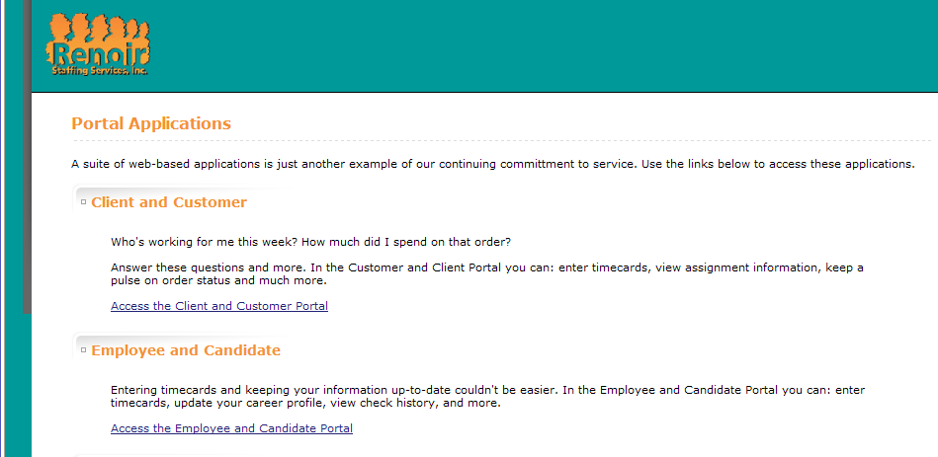
In the Portal Applications page, click on Access the Employee and Candidate Portal
- Log into eConnect with your Login ID and password.
- After logging in, the following window will be displayed:

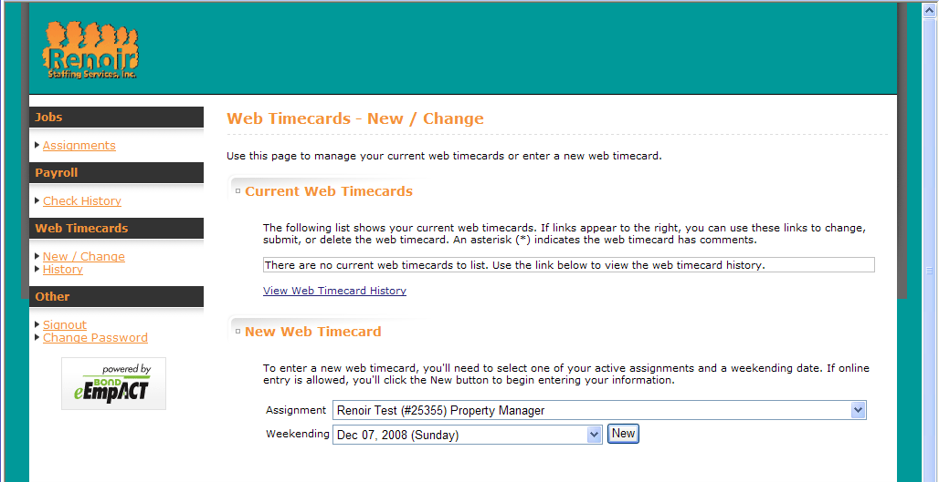
Creating a new timecard
  - Under the heading “New Web Timecard” are two drop down menus: “Assignment” and “Weekending.”
  - Select the appropriate assignment and weekending date from the drop-down list and press “New.”

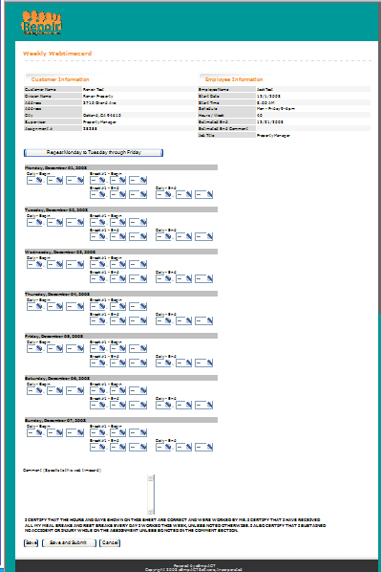
    - Enter your daily begin time, the beginning and end of your meal break (if applicable), and the daily end time for each day worked.

    - You can add a comment to your timecard. Doing so will send an email containing the comment to your Recruiter and will be displayed on the Timecard Details for your Assignment Supervisor and Recruiter when they access the timecard to approve or reject it.

    - Review the certification below the comment section before submitting your timecard for approval.

    - Once you have entered your time you will have the option to “Save and Submit” your timecard or “Save” your timecard without submitting it. If you choose to save but not submit your timecard you may access it later
under the “Recent Timecards” section of the “Web Timecards New/Change” page.
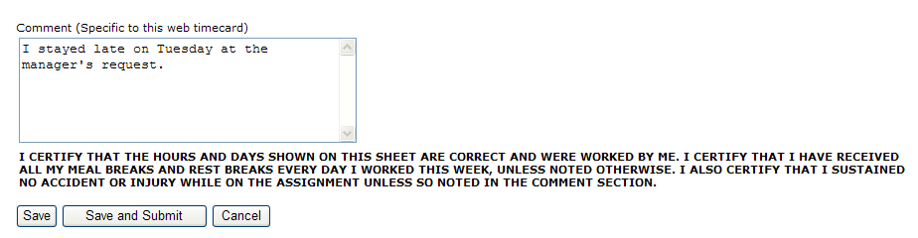
- Upon submitting your timecard you will receive an email from your Recruiter with the confirmation number as well as the timecard number.

Talk to your Recruiter to find out what other valuable information can be accessed through Tsheets!

Appendix G

Job Duty Exclusion List

The following areas of work are excluded from Elite Labor Solutions, Inc employees approved work list due to safety concerns.
Employees of Elite labor:
- May not perform any roofing work or inspect or repair any roof.
- May not use his or her own vehicle for the client's purposes.
- May not work on air conditioning unit or HVAC systems.
- May not work on or in electrical panels, boxes, and breaker boxes, sub panels or junction boxes.
- May not repair elevators or any of their equipment.
- May not repair or work on fire extinguishers, fire alarm systems or burglar systems.
- May not work on large plate glass window repairs.
- May not handle or work with dangerous or toxic chemicals.
- May not remove, work, touch or handle any asbestos issue on a complex including, but not limited to, insulation, floor covering, ceiling covering and so on.
- May not work on pool equipment.
- May not repair overhead doors or doors that automatically open.
If any Elite Labor employee is unclear or has questions about a particular job, they are directed to call their recruiter.

MEAL BREAK WAIVER AGREEMENT

I understand that California law gives me the right to certain unpaid meal breaks, as outlined below. In addition, I understand that California law gives me and my employer the right to mutually agree to waive meal breaks in certain situations, as outlined below. Accordingly, I agree to waive meal periods as follows:
First Meal Period:
- I understand that I am entitled to an unpaid meal break of not less than thirty (30) minutes for every five (5) hour period of time worked. However, I understand that I can waive the meal period when my total day’s work will be completed within a work period of not more than six (6) hours.
- Accordingly, I agree to waive the meal period whenever my total day’s work will be completed within a work period of not more than six (6) hours.
Second Meal Period:
- I understand that I am entitled to a second unpaid meal break of not less than thirty (30) minutes if I work more than ten (10) hours during a work day. However, I understand that I can waive the second meal period when my total day’s work will be completed within a work period of not more than twelve (12) hours, as long as I did not waive the first meal period.
- Accordingly, I agree to waive the second meal period whenever my total day’s work will be completed within a work period of not more than twelve (12) hours, as long as I did not waive the first meal period.
- I understand that this means that on days when my total day’s work will be completed in more than ten (10) hours but less than twelve (12) hours, I am waiving my second unpaid meal break, but that I must take my first meal break on such days.
I enter into this agreement freely and voluntarily. I understand that this agreement can be revoked in writing by either me or Elite Labor Solutions, Inc at any time.

Appendix K

Orientation Attendance

I have attended an Elite Labor Solutions, Inc Orientation and understand and agree to the policies and rules presented and discussed. These include, but are not limited, to:
- EEOC Policy
- Anti-Harassment Policies
- Timesheet/Payroll Policies
- Overtime Policies
- Safety Policies
- Site Key Policies
- Cash Handling Policies

A copy of this form will be presented to you for your signature

TRAINING ACKNOWLEDGMENT SIGNATURE SECTION
Employee Handbook Acknowledgment
01/01/17 EDITION

File this form in the Employee's Personnel Record

By accepting the position at Elite Labor Solutions, Inc., I acknowledge I have received a copy of rules and regulations and training on all items below and agree to comply with all rules, regulations, and guidelines placed into effect by my employer and their clients.

- Employee handbook 01/01/17 Edition
- Sexual harassment pamphlet

By signing below I have understood and accepted a position at Elite Labor Solutions, Inc.

Employee's Signature _________________________________________

Print Employee Name _________________________________________

Training/Hiring Supervisor ________________________________________

Date of Hire:____________________________________________________

Appendix L

Certificate of Acknowledgement of Receipt of the Employment Handbook and Review of Elite Labor Solutions, Inc. General Policies and Procedures

This certificate acknowledges that I received a copy of the Temporary Employment Handbook, which supersedes all prior personnel handbooks or Elite Labor Solutions, Inc., (Elite labor) employment policies. This certificate also acknowledges that I have reviewed the general policies and procedures required by Elite Labor with an Elite Labor employee. I understand that the employee handbook contains important information about Elite Labor’s general personnel policies, benefits and provisions that control my employment relationship with Elite labor.
I understand that this handbook is not an expressed or implied contract for a specific period of employment and does not form continuing or long-term employment between Elite Labor and me. It is, however, the final and complete understanding between us regarding my “at-will” employment status. This means that I am free to end my employment at any time, for any reason, with or without cause, and Elite Labor retains the same right. I also understand that no amendment or exception to our at-will policy can be made at any time, for any reason, except in writing by the Human Resource Manager or President of Elite labor.
I acknowledge that Elite Labor reserves the right to change any provision in this handbook at any time for any reason without advance notice. Though Elite Labor can make changes, I understand that nothing in this Handbook can be modified or deleted, nor can anything be added in any way by oral statements or practice. Only Elite Labor can change this Temporary Employment Handbook, and the change must be in writing. If Elite Labor makes any material changes, they will give me a copy of the changes.

A copy of this form will be presented to you for your signature

By signing below I have understood and accepted a position at Elite Labor Solutions, Inc.

Employee's Signature _________________________________________

Print Employee Name _________________________________________

Training/Hiring Supervisor ________________________________________

Date of Hire:____________________________________________________

Appendix M

Occupational Medical Facilities

Locations:
US Healthworks

NOTES

